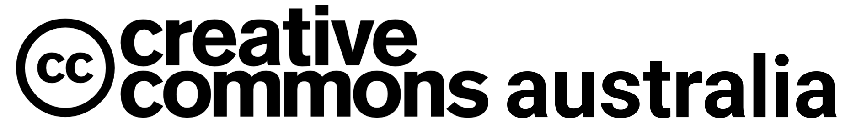

Copyright Amendment (Access Reform) Bill 2021 exposure draft and the review of technological protection measures (TPMs) exceptions Submission
Friday 25 February 2022

About Creative Commons globally
Creative Commons (CC) is a nonprofit organisation that helps overcome legal obstacles to the sharing of knowledge and creativity to address the world’s pressing challenges. It strives for its vision and delivers on its mission through stewardship of free, simple and standardised Creative Commons licences and public domain tools (CC legal tools). By extension, CC supports the CC Global Network to drive adoption of its tools and build a community of advocates and knowledgeable interpreters. To that end, CC also produces events like the CC Summit and provides education such as the
CC Certificate program.
https://creativecommons.org/about

About CC in Australia
Creative Commons Australia (CC Australia) is the local Chapter of the CC Global Network. CC Australia promotes and encourages the use of CC licences in Australia. We coordinate Chapter meetings and working groups, organise engagement events and share global news with the Chapter and our communities. CC Australia is an informal community of practice made up of interested individuals and organisations working collaboratively to realise the potential of CC in Australia and our region.
https://au.creativecommons.net/about

Introduction
CC affirms the importance of copyright. That’s because, at the heart of CC is a suite of copyright licences. CC relies on copyright law for enforceability. Good copyright policy is important for the proper operation of the CC licences. It is for this reason that the CC international organisation and its regional chapters – including CC Australia – are committed to engaging in copyright reform processes: ‘CC licenses are a patch, not a fix, for the problems of the copyright system.’
CC Australia supports the reforms proposed in the Copyright Amendment (Access Reform) Bill 2021 (the Bill). We do so because we encourage copyright law reform that ensures the effective operation of copyright in an online world. Voluntary licensing schemes like CC are an important part of the copyright ecosystem, but should not be thought of as a comprehensive solution for access to and reuse of knowledge and creativity. Copyright needs law and policy reform that has the public interest at heart. If enacted, the Bill will continue the modernisation of Australia’s copyright system by ensuring it can accommodate contemporary use of copyright material in the public interest, without undermining incentives for copyright owners.
The reforms come as Australia and the world adapts to living in a pandemic. For creators, producers and venues, COVID-19 has disrupted the typical path for creating and presenting creative content. By necessity, how the public engages with a range of public institutions – including galleries, libraries, archives and museums (GLAM), education providers, research organisations and governments – has also changed. Social distancing, lockdowns and other preventative measures designed to slow the spread of Coronavirus accelerated the need for services to be delivered remotely. The sudden shift to online service delivery quickly exposed the inadequacy of the Copyright Act 1968 (the Act) to support and facilitate the digital delivery of copyright-protected content. The Bill will go a long way to addressing those inadequacies if it is passed.
Stimulating reuse of orphan works, supporting quotation in a range of scenarios, facilitating equitable access to cultural collections, further enabling online education and embracing government services that are digital by design are all worthwhile endeavours that harmonise with CC’s vision and mission:
- Vision: ‘A world where knowledge and culture are equitably shared in ways that serve the public interest’.
- Mission: ‘Creative Commons empowers individuals and communities around the world by equipping them with the technical, legal and policy solutions to enable sharing of knowledge and culture in the public interest.’
We support the ability to use copyright material in modern creative endeavours. CC uses the tagline ‘some rights reserved’. This string of words is effective shorthand for CC’s purpose.
In addition to our broad support of the reform package, this submission will provide specific comments on some aspects of the Bill and points raised in the discussion paper.
CC Australia thanks the Department of Infrastructure, Transport, Regional Development and Communications (the Department) for the opportunity to make comments on the exposure draft of the Bill. If the Department requires any further information from CC Australia, we can be contacted at info@creativecommons.org.au.

Limitation on remedies for use of orphan materials
The CC licences are a mechanism through which copyright owners can easily allow reuse of their copyright material on specified terms. While CC is a worthwhile option for creators of contemporary content to enable access to their material on specified terms, orphan materials (i.e. situations where the copyright owner of material is unknown or cannot be contacted) pose a different challenge. CC licences must be applied by the copyright owner, and so cannot be used where the copyright owner is unknown. As such, limiting the remedies available to a copyright owner of formerly orphaned material that was used by someone else will address an access gap that cannot be solved by any form of licensing.
CC Australia supports the scheme covering all types of orphaned copyright material; in the digital world it is not necessary to differentiate between different types of creative output. Further, increasingly content is less dependent on the original medium, format, technologies or platforms used to create or disseminate it. We also support the scheme applying broadly to any use of orphaned material by any user.
The drafting of the provisions includes a range of appropriate measures to protect copyright owners of orphan materials. To illustrate, users can only rely on the scheme where the copyright owner of material cannot be identified or is unresponsive to requests for permission to use the material. To determine if the material is truly orphaned, a user must undertake a reasonably diligent search to identify the copyright owner. The scheme provides a non-exhaustive set of fairness factors which alert users to the types of matters they should be mindful of when conducting searches, while also anticipating the need for flexibility and context. Lastly, the ability for the parties to negotiate terms for the ongoing use of formerly orphaned materials where a copyright owner is later identified is another example of striking a balance between the interests of users and copyright owners. For a more detailed discussion of how the orphan materials scheme balances the interests of users and copyright owners we recommend the Department review the joint submission of the Australian Digital Alliance (ADA) and the Australian Libraries and Archives Copyright Coalition (ALACC), both institutional members of CC Australia.

New fair dealing exception for quotation
While we have some concerns about the narrow scope of the proposed fair dealing for quotation provision, CC Australia supports the introduction of a mechanism for quotation of copyright materials. This new exception will provide certainty for public bodies and researchers operating in a digital environment and reflect accepted academic practice around the dissemination and exchange of information. Attempting to obtain permission to include quoted material can be a difficult and time-consuming process for all parties.
This is especially so in research contexts, where research outputs can include many instances of quoted third-party materials. The proposed fair dealing for quotation exception will support the dissemination of research by reducing the burden placed on researchers and research organisations in relation to quoted material and allow researchers to include third-party quoted material in published or communicated research outputs. This will make it easier and quicker to get accurate research and information out to the research community and the public.
We note that there is a trend in some areas of academic publishing towards open access (OA) – which relies on open licences, primarily CC licences, to facilitate broad public access to and reuse of OA materials. While CC licences can be applied to material by a copyright owner, the permissions granted under the licence do not apply to any quoted third-party material. Whether the academic output is published OA or through traditional academic publishing methods, all research will benefit from the new quotation provision.
We are concerned that the quotation exception will only cover material that has been ‘made public’. In response to Question 2.1 posed in the discussion paper, CC Australia fully supports extending the fair dealing for quotation exception to quotation of unpublished material. Beyond material that is published, there are wide quantities of unpublished materials that are important sources for quotation. One category of such material is unpublished content in libraries, archives and cultural collections. Excluding such material will make the application of the provision unnecessarily complicated, run the risk of creating a chilling effect on lawful quotation and will be marred by practical issues such as the administrative burden of determining the nature of material users intend to quote and the inability in some situations to determine where the content has ever been lawfully ‘made public’.
CC Australia is also concerned that the scope of the proposed exception is limited to a set of identified users only, leaving quotation by the public outside the protection of the new provision. The value of the provision could be expanded greatly by removing the limitations to its scope. We support the comments made by the ADA and ALACC that limiting who can quote material, what material can be quoted and the types of uses that can be made will compromise the utility of the proposed fair dealing for quotation. We also agree with those organisations when they say that ‘[b]roadening the scope to include any user would bring copyright law closer to the normative expectations the public has with regards to quotation of material, freedom of speech and public discourse in a democracy.’

Attribution practices
In addition to our general comments on the new fair dealing for quotation exception we would also like to bring to the attention of the Department the parallels between how the CC licences require attribution of the author and how the same matter is addressed in the moral right of attribution and the proposed requirement to identify the title or name of the copyright material included in subcl 113FA(1)(e) of the Bill. Attribution by identifying the creator of CC-licensed material is required when using any material available under a CC licence. CC also recommends that the title of the material be identified. CC encourages flexibility in relation to attribution. Its information on best practice for attribution, for example, encourages attribution in ways that are reasonable to the medium. CC licences also permit a copyright owner to request how they would like to be identified, so long as the request is reasonable. Similar obligations arise under Part IX of the Act and the new fair dealing for quotation provision, if enacted.
Of course, a use legitimately made under the quotation exception would not require compliance with the CC licence. However, the attribution practices that have emerged over the 20 years of CC are a valuable contribution to the topic of attribution in copyright more broadly.

Updating and clarifying the library and archives exceptions
CC Australia welcomes and supports the updates and clarification to the libraries and archives exceptions proposed in the Bill. We acknowledge that good work has been undertaken in relation to exceptions for cultural institutions in recent years, including the reforms that were part of the Copyright Amendment (Disability Access and Other Measures) Act 2017. These updates will continue that. They will reduce the administrative burden on collections, enable greater online access to cultural and information material for the Australian community and will support collections to respond to reasonable requests from the public.
We support broadening the scope of the document delivery and interlibrary loans provisions to cover any copyright material. We also support extending the document delivery and interlibrary loans, use of unpublished copyright material and the use of unpublished theses or similar literary works provision to include ‘private and domestic’ uses. Doing so will increase the value and the utility of each provision.
CC Australia also welcomes the proposal to make more collections materials available for access online. The provision will provide all Australians more equitable access to cultural material, much of which is, in practice, limited to parties who have the means to travel to a capital city or a major centre to access materials onsite.

Updating the educational and government exceptions
The global pandemic has demonstrated how important it is that schools are able to provide online access to educational material. We support copyright changes that will make it easier for schools to use contemporary teaching methods and provide quality learning experiences online. Applying the provision to any copyright material recognises the increasing importance of audio-visual content in learning environments.
Similarly, CC Australia supports the proposed changes that will better enable the delivery of government information and services online. Beyond convenience, there are strong public interest reasons that encourage greater use of the internet in the delivery of government information, programs and initiatives.
As a final point, many GLAM bodies, education providers and government agencies already release materials under CC licences. CC Australia encourages greater uptake of CC licences for disseminating content created by these types of organisations where appropriate. This can assist the dissemination of important information and online services to the public.
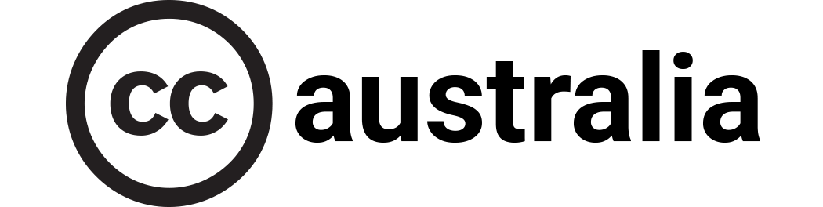

The definition of ‘open access’ included in the Budapest Open Access Initiative (BOAI) reads: ‘By “open access” to [peer-reviewed journal] literature, we mean its free availability on the public internet, permitting any users to read, download, copy, distribute, print, search, or link to the full texts of these articles, crawl them for indexing, pass them as data to software, or use them for any other lawful purpose, without financial, legal, or technical barriers other than those inseparable from gaining access to the internet itself. The only constraint on reproduction and distribution, and the only role for copyright in this domain, should be to give authors control over the integrity of their work and the right to be properly acknowledged and cited.’ See Open Society Foundations (2001) Budapest Open Access Initiative. Available at https://www.budapestopenaccessinitiative.org/read/. See also, Max Planck Society for the Advancement of Science (2003) Berlin Declaration on Open Access to Knowledge in the Sciences and Humanities. Available at https://openaccess.mpg.de/Berlin-Declaration.
See for example section 3(a) of the legal code for the Creative Commons Attribution 4.0 International (CC BY 4.0) licence.
See for example section 2(a)(2) and the definition of ‘exceptions and limitations’ in section 1(e) of the legal code for the CC BY 4.0 licence.

